**MATERIALS AND METHODS**

**Virtual Screening and Dockkng Plaform**

Schrödinger Suite software and Maestro 12.8 were used to conduct computer-based drug screening (Schrödinger 2021). A total of 50 compounds that have been described with *Bambara nut (Vigna subterranea)* were retrieved from an online data base, PubChem

(https://pubchem.ncbi.nlm.nih.gov/) and docked to the active site of Superoxide Dismutase ( PDB ID: 1AP5) to predict compounds with the best binding affinity.

**Ligand Preparation**

A compound library for Bambara nut (Vigna Subterranea) used in this research was were gotten from published literatures. The ligands were retrieved from the NCBI PubChem database (https://www.ncbi.nlm.nih.gov/pccompound) in two-dimensional (SDF) format. The ligands underwent preparation utilizing the LigPrep module within the Maestro 12.8 interface of the Schrodinger suite 2021. These ligands were subsequently transformed from two-dimensional to three-dimensional structures by incorporating stereochemical configurations, ionization states, tautomeric forms, along with energy minimization procedures and geometric optimization, followed by desaltation and rectification of chiral centers and absent hydrogen atoms. The bond orders pertaining to these ligands were standardized, and the charged moieties were rendered neutral. The ionization and tautomeric states were systematically generated within a pH range of 7.0 ± 2.0 employing the Epik module. In the LigPrep module, the ligands were subjected to minimization utilizing the Optimized Potentials for Liquid Simulations (OPLS3) force field. A single low-energy ring conformation for each ligand was produced, and the optimized ligands were subsequently employed for docking analysis (Shi et al.,2017).

**Protein Selection and Preparation**

The crystal structure of protein Superoxide dismutase was retrieved from

Protein Data Bank ((http://www.rcsb.org/pdb/home.do) having the PDB ID : 1AP5. The three-dimensional structure was analyzed utilizing the maestro 12.8 interface. Generally, the protein conformations are meticulously refined concerning their bond orders, formal charges, and the presence of missing hydrogen atoms, as well as their topologies, incomplete terminal amide groups, and absent side chains. Water molecules positioned beyond 5 Å were systematically eliminated. The potential ionization states were generated within the protein conformation, from which the most thermodynamically stable state was selected. Hydrogen bonds were systematically assigned, and the orientations of the retained water molecules were rectified accordingly. Ultimately, a minimization procedure of the protein structure was executed employing the OPLS3 force field to effectively reorient side-chain hydroxyl groups and mitigate potential steric clashes. This minimization process was constrained to the original protein coordinates by a predefined Root Mean Square Deviation (RMSD) tolerance of 0.3 Å.

**Receptor Grid Generation**

The receptor grid panel was utilized to establish the grid creation task and to specify a receptor configuration. The receptor grid illustrates the spatial region wherein the ligand and protein engage in interaction. The Receptor Grid Generation tool facilitated the creation of the prepared protein grid at the binding site (Glide Grid). The selection of the co-crystallized ligand located at the active site of 1AP5 elucidated the binding position. An automatically generated cubic grid box encompassed all amino acid residues present at the active site. The generated grid's three-dimensional coordinates encompass the X, Y, and Z dimensions were 12.07 Ao, -33.87 Ao, and 60.51 Ao, respectively.

**Molecular Docking**

The molecular docking process was performed using the Glide

tool, utilizing Maestro 12.8 software. The 50 compounds library was docked docked into the prepared grid of protein targets utilzing the extra precision (XP) mode. The docking process was run in a flexible docking mode which automatically generates conformations for each input ligand.

The ligand poses generated were passed through a series of hierarchal filters that evaluate the ligand's interaction with the receptor (Olugbogi et al.,2022).

**Molecular mechanics grown born surface area.**

Generalized molecular mechanics A computational technique called born surface area (MM-GBSA) is used to determine the energy of different molecular system constituents, such as optimal free receptors, free ligands, and the complex created when a ligand binds to a receptor. Furthermore, by immersing the ligand in a solvent environment produced by the VSGB 2.0 suite, it makes it possible to assess the ligand strain energy. The OPLS3 force field, the VSGB solvent model, and Prime rotamer search methods from Maestro were used in this investigation. The required computations and simulations were carried out using these tools and models. The following formula was used to calculate the binding free energy, which measures how strongly the ligand and receptor interact:

∆G bind = G complex p X - (G protein + G ligand)

This equation takes into account various energy contributions from the molecular system and provides valuable insights into the binding affinity between the ligand and receptor (Bodun et al., 2023).

**ADMET/Tox screening**

A key component of the drug discovery process is the analysis of ADME, which offers important insights into how drugs behave in biological systems.25 In this study, we used the SwissADME (http://www.swissadme.ch) server to predict the drug-like properties and potential toxicity of the chosen lead compounds and the standard compound. To assess the compounds' drug likeness, we used the Lipinski rule, which includes five essential criteria for determining oral activity.26 The results, shown in Table 2, show that all of the chosen compounds have favorable physicochemical properties, such as low molecular weight, a desirable bioavailability score, and good solubility.

**Results and Discussion**

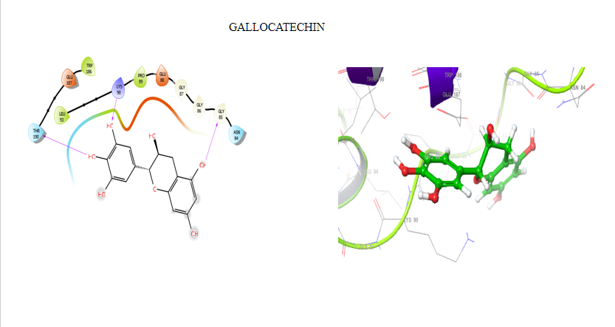

Fig 3. 2D and 3D Protein-ligand interaction of Gallocatechin against

SOD

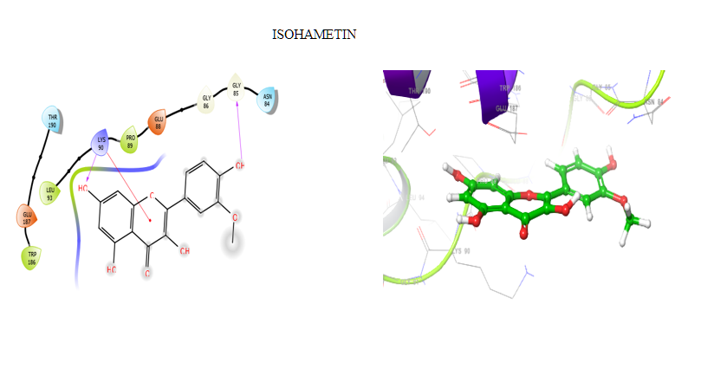

Fig4. 2D and 3D Protein-ligand interaction of Isoharmetin against

SOD

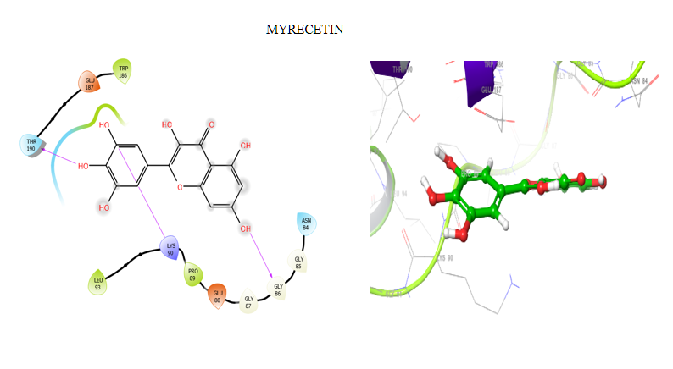

Fig 5. 2D and 3D Protein-ligand interaction of Myrecetin against

SOD

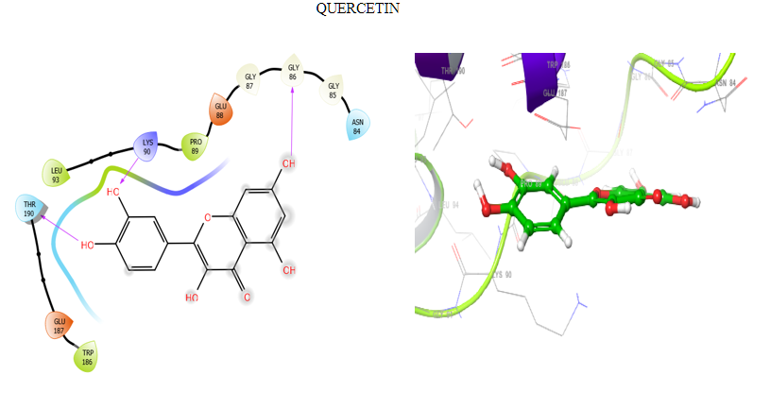

Fig 6. 2D and 3D Protein-ligand interaction of Quercetin against

SOD.

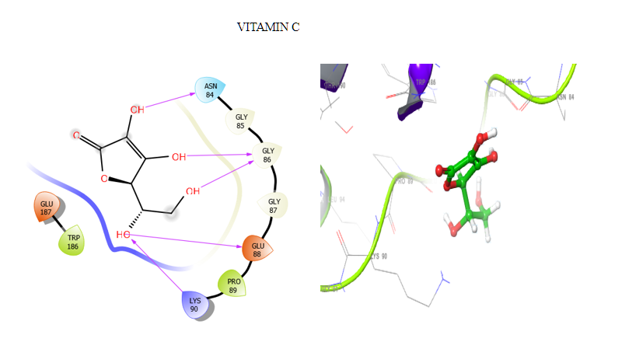

Fig 7. 2D and 3D Protein-ligand interaction of Vitamin C against SOD.

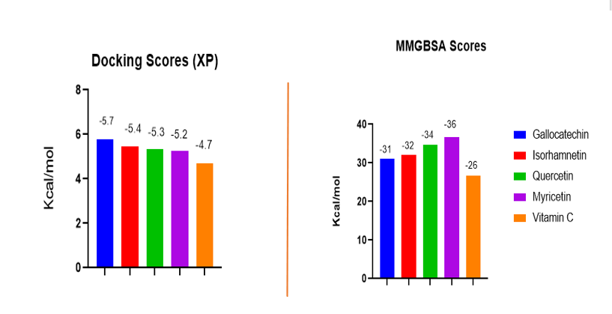

Fig 8. Docking and MMGBSA score

Table 1: Docking and MMGBSA scores of Top 4 compounds

|  |  |  |  |
| --- | --- | --- | --- |
| **Entry Name** | **PubChem ID** | **docking score** | **MMGBSA dG Bind** |
| Gallocatechin | 6508 | -5.794 | -31.06 |
| Isorhamnetin | 5281654 | -5.452 | -32.02 |
| Quercetin | 5280343 | -5.347 | -34.63 |
| Myricetin | 5281672 | -5.272 | -36.74 |
| Vitamin C (ascorbic acid) | 54670067 | -4.705 | -26.67 |

The molecular docking analysis identified four compounds from vigna subterranea (Bambara nut ) that showed strong binding affinity for the target protein onstrated strong inhibitory potential against the target enzyme, with docking scores comparable to the standard compound Vitamin C ( Figure 8). A more negative docking score indicates a higher binding potential. The gallocatechin, isorhamnetin, quercetin and myricetin with docking scores of −5.794, –5.452, –5.347, –5.272 kcal/mol, respectively, compared to the docking score of −4.705 kcal/mol for Vitamin C (ascorbic acid), which is the standard drug (Table 1). All four Vigna subterranea compounds outperform Vitamin C in both docking and MMGBSA scores. Myricetin stands out with the most favorable MMGBSA score (-36.74 kcal/mol), suggesting it forms the most stable complex with SOD. Gallocatechin has the highest docking score (-5.794 kcal/mol), indicating strong initial binding affinity. These results suggest that the Vigna subterranea compounds are superior candidates for SOD binding compared to Vitamin C.

Table 2: In- silico drug likeness prediction of the compounds

|  |  |  |  |  |  |  |  |  |
| --- | --- | --- | --- | --- | --- | --- | --- | --- |
| **Entry name** | **PubChem ID** | **MW** | **HBA** | **HBD** | **TPSA** | **ILOGP** | **LOGKP** | **ROV** |
| Isorhamnetin | 5281654 | 316.06 | 7 | 4 | 120.36 | 2.35 | -6.9 | 0 |
| Gallocatechin | 6508 | 306.07 | 7 | 6 | 130.61 | 1.47 | -8.17 | 0 |
| Myricetin | 5280343 | 318.04 | 8 | 6 | 151.59 | 1.08 | -7.4 | 1 |
| Quercetin | 5281672 | 302.04 | 7 | 5 | 131.36 | 1.63 | -7.05 | 0 |
| Vitamin C | 54670067 | 176.03 | 6 | 4 | 107.22 | -2.06 | -8.62 | 0 |

**ADME/Tox screening**

An essential step in the drug development process is the investigation of ADME, which offers important insights into how medications behave in biological systems (Kar et al., 2020). To forecast the drug-like characteristics and possible toxicity of the chosen lead compounds and the standard compound, we used the Swissadme and Admet server in this investigation. We used the Lipinski rule of five, which includes five essential criteria for assessing oral action, to assess the compounds' drug similarity (Lipinski et al., 2024). All of the slected compounds have strong physicochemical characteristics, such as low molecular weight, a suitable bioavailability score, and good solubility, according to the results, which are shown in Table 2.

Table 3 The bio-availability, pharmacokinetic properties and Cytochrome P450 metabolizing enzymes bninding potentials of selected vigna subterranea phytochemical constituent

|  |  |  |  |  |  |
| --- | --- | --- | --- | --- | --- |
| **Models** | **Gallocatechin** | **Isorhamnetin** | **Myricetin** | **Quercetin** | **Vitamin C** |
| Blood Brain Barrier | No | No | No | No | No |
| Bioavailabilty score | 0.55 | 0.55 | 0.55 | 0.55 |  |
| CYP1A2 inhibition | No | Yes | Yes | Yes | Yes |
| CYP2C9 inhibition | No | No | No | No | No |
| CYP2C19 inhibition | No | No | No | No | No |
| CYP2D6 inhibition | No | Yes | No | Yes | No |
| CYP3A4 inhibition | No | Yes | Yes | Yes | Yes |
| P-glycoprotein substrate | No | No | No | No | No |
| QED | 0.437 | 0.572 | 0.371 | 0.434 | 0.385 |
| GI absorption | High | High | Low | High | High |
| Mutagenicity | No | Yes | No | No | No |
| Carcinogenicity | No | Yes | Yes | Yes | Yes |
| Genotoxicity | No | Yes | No | No | No |
| Neurotoxicity | No | Yes | Yes | Yes | Yes |

Gallocatechin and Quercetin show favorable ADMET profiles with high GI absorption, no BBB penetration, and no P-glycoprotein substrate activity. Gallocatechin’s minimal CYP inhibition makes it particularly promising for avoiding drug interactions. Isorhamnetin also performs well but inhibits multiple CYP enzymes. Myricetin’s low GI absorption and CYP inhibition may limit its pharmacokinetic suitability. Vitamin C shares similar ADMET characteristics but has broader CYP inhibition, potentially complicating its use in polypharmacy. QED values range from 0 to 1, with higher values indicating better drug-likeness. Isorhamnetin has the highest QED (0.572), suggesting it is the most drug-like. Myricetin has the lowest (0.371), possibly due to its Lipinski violation and low GI absorption. All values are moderate, indicating acceptable but not optimal drug-likeness.

**Conclusion**

Superoxide dismutase (SOD) is a critical antioxidant enzyme that neutralizes superoxide radicals, protecting cells from oxidative stress and associated diseases. The Vigna subterranea compounds—Gallocatechin, Isorhamnetin, Myricetin, and Quercetin—demonstrate superior binding to SOD compared to Vitamin C, enhancing their potential to support SOD’s antioxidant activity. Myricetin exhibits the most stable binding (MMGBSA dG Bind = -36.74 kcal/mol), suggesting it may effectively stabilize SOD’s active site, boosting its capacity to combat oxidative damage. Gallocatechin, with the highest docking score (-5.794 kcal/mol), shows strong initial binding affinity, indicating it could efficiently interact with SOD to enhance its radical-scavenging function. Isorhamnetin and Quercetin also display favorable binding profiles, supporting their role in augmenting SOD’s antioxidant defense.

In terms of drug-likeness, Isorhamnetin and Quercetin fully comply with Lipinski’s Rule of Five, while Myricetin and Gallocatechin have minor violations. ADMET screening highlights Gallocatechin and Quercetin as top candidates due to high GI absorption, minimal CYP inhibition (especially for Gallocatechin), and favorable QED scores, making them suitable for therapeutic applications targeting oxidative stress. Isorhamnetin is promising but requires caution due to CYP inhibition. Myricetin’s low GI absorption may limit its efficacy despite its strong SOD binding. The antioxidant potential of these compounds, particularly Gallocatechin and Quercetin, through their interaction with SOD, positions them as promising candidates for combating oxidative stress-related disorders, offering improved binding and pharmacokinetic profiles over Vitamin C.

References

1. Schrödinger Release 2021–1: Epik, Schrödinger, LLC, New York. https://www. schrodinger.com/citations
2. Schrödinger LLC (2017) Schrödinger, LLC, New York. Schrödinger Suite, 2, 2017-1
3. Shi PW, LiliCK, WangJieZ J. Co (III)- Catalyzed Enaminone-Directed C-H Amidation for Quinolone Synthesis. Organic Letters. 2017;19:2418–2421.
4. Bodun DS, Omoboyowa DA, Adedara JF, et al. Virtual screening of flavonoids from Blighia sapida against ERK5 involved in breast cancer. Proc Indian Natl Sci Acad. 2023;89:957-966.
5. Olugbogi EA, Bodun DS, Omoseeye SD, et al. Quassia amara bioactive compounds as a Novel DPP-IV inhibitor: an in-silico study. Bull Natl Res Centre. 2022;46:1-14.